**Exercise- 3**

**Step 1 : Create a new branch and name it GitNewBranch:**

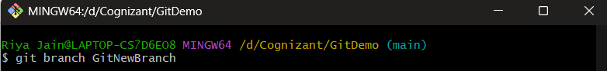

**Step 2: Listing all local and remote branches:**

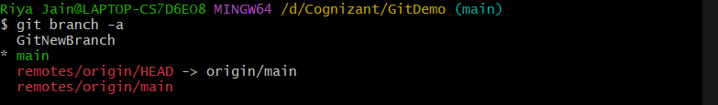

**Step 3: Switching to the new branch.**



**Step 4: Commit changes.**

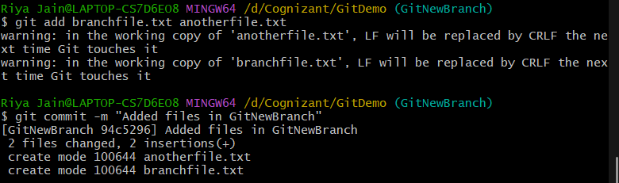

**Step 5: Checking the status.**

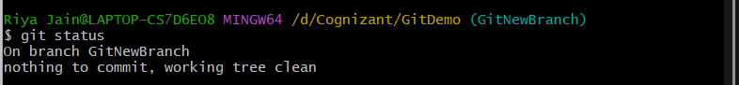

**Step 6: Switching to main from master.**

**Step 7: Listing differences between trunk and branch(CLI).**

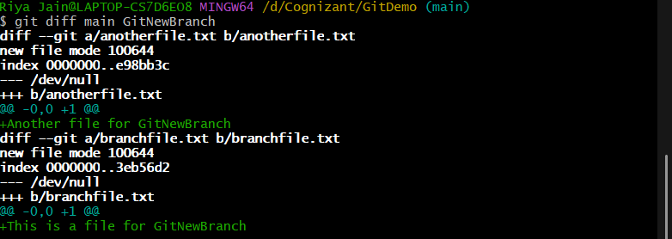

**Step 8: Merging source branch into trunk.**

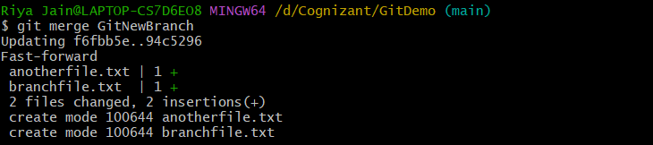

**Step 9: Log showing merge commit.**

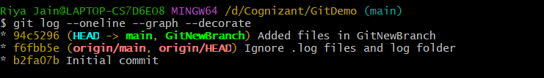

**Step 10: Deleting the new branch.**



**Step 11: Checking the status.**

